**Northeastern University**

360 Huntington Ave, Boston, MA 02115



**Report on**

**Photomosaicing**

**LAB_5** - EECE 5554 Robotics Sensing and Navigation

**Submitted by:**

**Pavan Rathnakar Shetty**

**Submitted to**

**Hanumant Singh**

**Professor, Electrical and Computer Engineering**

The image stitching for the 3 different image datasets is given in stitch.m, stitchparker.m and stitchgraf.m files.

Stitch.m - Forsyth street Images

Stitchparker.m - Brickwall Images

Stitchgraf.m - Graffiti Art with 15% overlap

Part 2:

Camera Calibration:

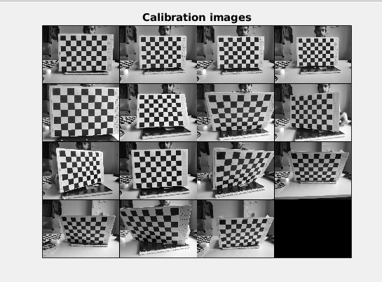

After Calibration:

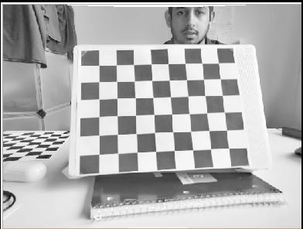

There is not much change because modern phones are already calibrated.

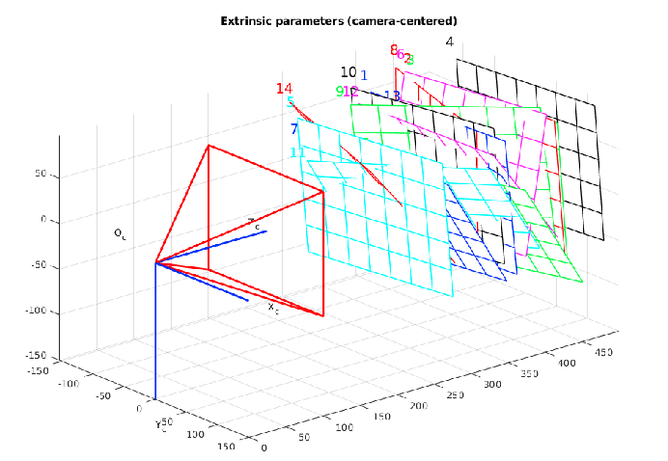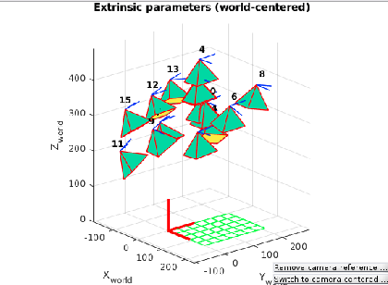

The error is described in Calib_Results.m file.

Part 3: 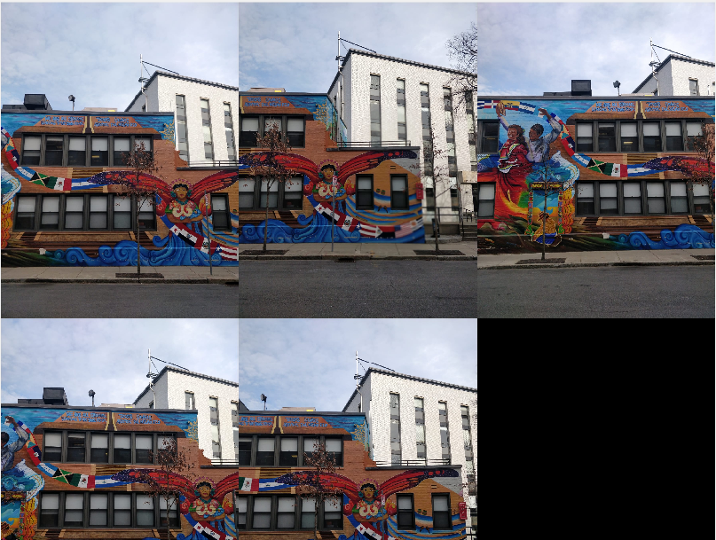

Forsyth Street Images

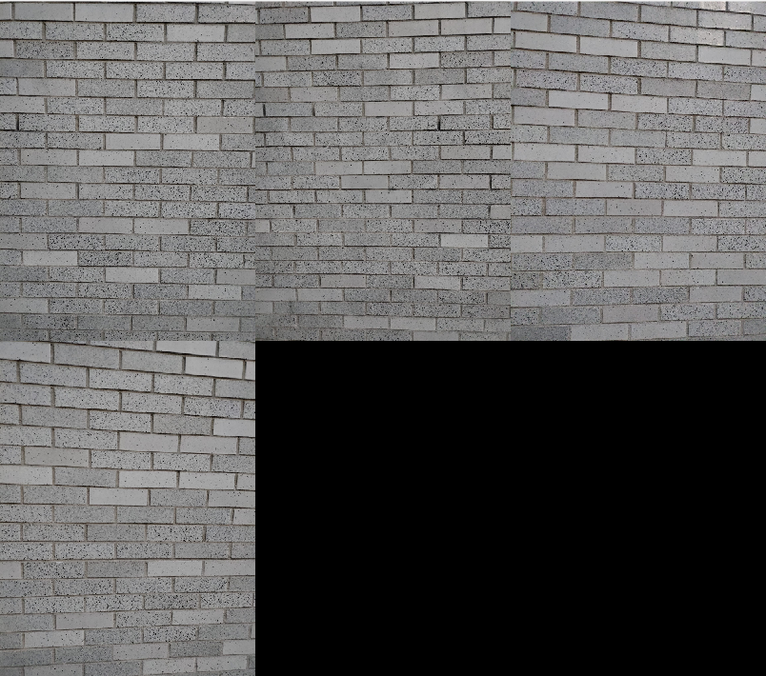

Cinder Block Images

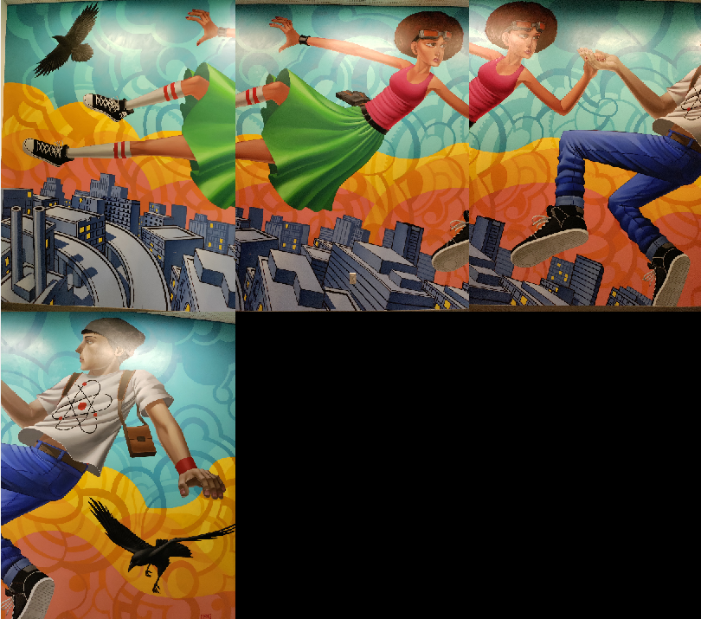

**Images for 15% overlap.**

**Part 4:**

**Harris Corner**

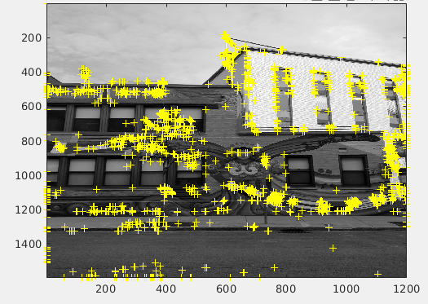

**Part 5:**

**Mosaics**

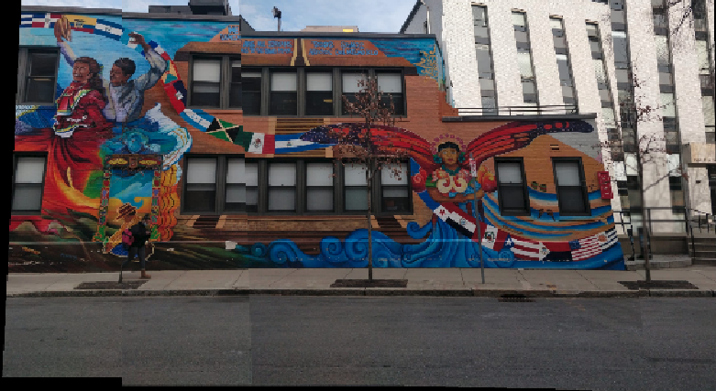

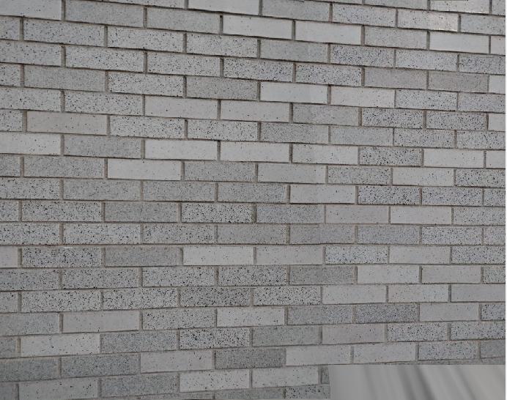

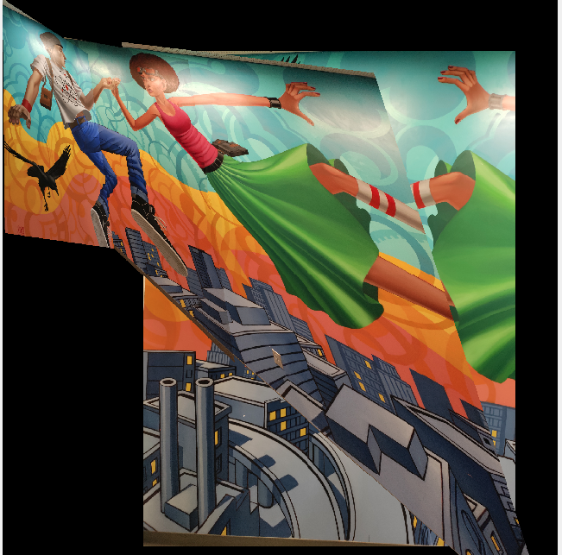

**Part 6:**

**The parameters like the number of features to be detected and block size were a few parameters I played around.**

**In the cinder block, most of the features were matched with subsequent images and were mapped wrongly because of the uniformity and less differentiating features in the image because of repeating patterns in the brick and I had to change the parameters to get the right mosaicing.**

**Fixing light was also a problem and I had to retake the datasets for better feature extraction.**

**For mosaicing of Grafitti images, I had to increase feature points from 1500-8000 since the overlap changed from 50%-15% and the panorama stitching needs more harris corners for mapping the points. It also increased computational requirements from the GPU and I had to play around with fixing my GPU drivers in my Asus Zephyrus Laptop more than the assignment.**

**Part 7:**

**Image Datasets used:**

**Calib Image for Calibration.**

**Memorial for Forsyth street images with 50-60%overlap.**

**Graf for 15% overlap.**

**Brickbw for cinder block photomosaicing.**